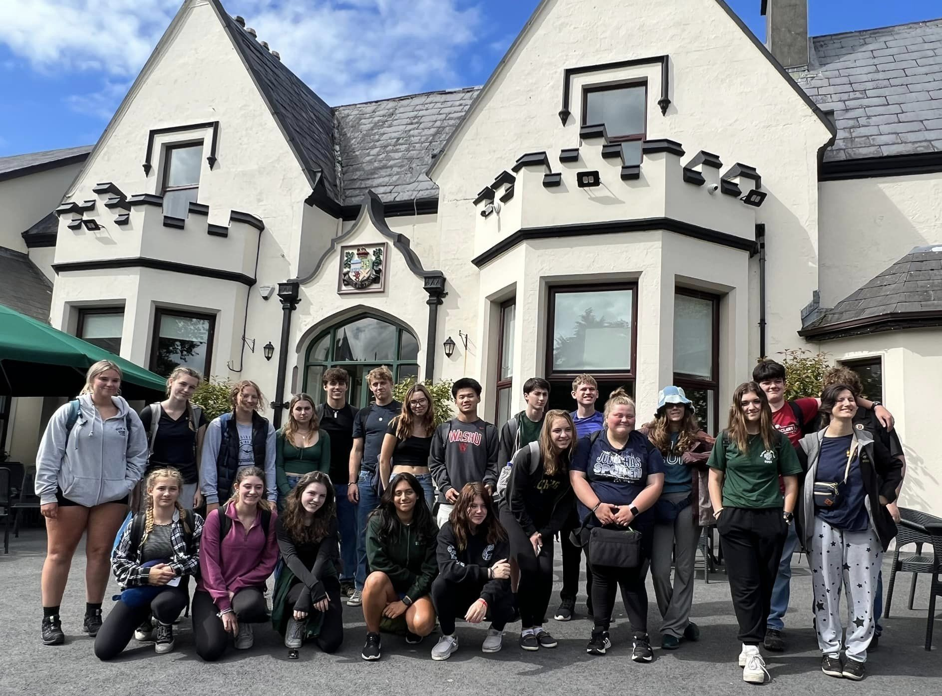

HVRHS International Travel Club
The HVRHS International Travel Club was founded to provide students with authentic learning opportunities that extend far beyond the walls of Housatonic...and even our own country. We believe all students should be able to broaden their worldviews through an exploration of art, history, language, and cuisine. The power of travel cannot be understated, and we intend the overseas journeys we take to be life-changing experiences for our students.

Our trips offer students the opportunity to...
* engage in service learning focused to the needs of the countries we visit
* develop empathy for different cultures and communities
* practice their foreign language skills
* earn high school and college credit

Fundraising: We want international travel experiences to be available to as many students as possible, and we strive to ensure that cost is not a prohibitive factor for students and their families. Opportunities for fundraising, through our sister organization, Northwest Corner: Students Without Borders, will be available to all who are able and willing to commit themselves to pursue their dreams of international travel. A huge part of our success is due to the incredibly supportive community of Region One. In the past, we’ve organized the following fundraisers:

* Dinners for the community
* Holiday appeals
* Live and silent auctions
* Car washes
* Bake sales
* ... and more!

Where we’ve been…

*China *Costa Rica *Ecuador *France *The Galapagos *Greece

*Germany *Iceland *Italy *Ireland *Japan *Portugal *Scotland

And where we’re going!
- Italy/Germany (April 2025) - enrollment FULL
- Thailand (July 2025) - enrollment FULL
- France/England (April 2026), enrollment is OPEN! https://www.eftours.com/tour-website/2856113NY
- Australia/New Zealand (July 2026), enrollment is OPEN! https://www.eftours.com/tour-website/2855187JH

For more information about the HVRHS International Travel Club, and the upcoming travel opportunities available to students, please reach out to one of our four advisors. Enrollment for our 2026 trips is open now!

Letitia Garcia-Tripp - lgacia-tripp@hvrhs.orgr
John Lizzi - jlizzi@hvrhs.org
Danielle Melino - dmelino@hvrhs.org
Taylor Tavera - ttavera@hvrhs.org

