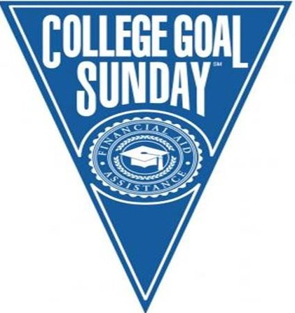
NAUGATUCK VALLEY COMMUNITY COLLEGE SUNDAY, JANUARY 31, 2016 1:30 p.m. TECHNOLOGY HALL
We can help you get money for college!
What is College Goal Sunday?
The College Goal Sunday program was created by Indiana Student Financial Aid Association with funding from Lilly Endowment, Inc. and supplemental support from the Lumina Foundation for Education. College Goal Sunday is a free, on-site program utilizes financial aid professionals and community-based service providers to assist students and their families with completing the Free Application for Federal Student Aid (FAFSA).
What should you bring?
- Your Social Security card or number
- Driver’s License (if applicable)
- W-2 forms for 2015 and other records of money earned
- Your parent’s Federal Income Tax Return for 2015 (If you are dependent student as defined by federal criteria)
- Your (or your spouse’s, if you are married) 2015 Federal Income Tax Return
- Your untaxed income records for 2015- Social Security, Temporary Assistance to Needy Families, welfare, or veterans benefits records
- Your current bank statements
- Your current business and investment mortgage information, farm records, stock, bond, and other investment records
- Proof that you are a U.S. permanent resident or other eligible non-citizen
Not all families will have all of the above information. Please attend College Goal Sunday and bring whatever documentation you have available.
What should you do to participate?
To participate or find further information about College Goal Sunday, you should visit our website, www.collegegoalsundayct.org, and fill out the student information form, or contact Anita Pelletier at apelletier@nv.edu or 203-575-8274
